MEMBERS AND FRIENDS OF CEDAR MAR
Cedar Mar Yacht Club’s 2024 season has begun with the annual Winter Educational Seminar at Adrian Hall February 24. Thanks must go first and foremost to Jim Berrien for his untiring efforts putting the event together. We would not have gotten it off the ground without Steve Stallsmith’s projector, Joe Balogh’s screen, Wendy Clark’s “quartermastering” and the food troops doing set-up/back-up/clean-up. Without the concerted efforts of so many it would not be the same.
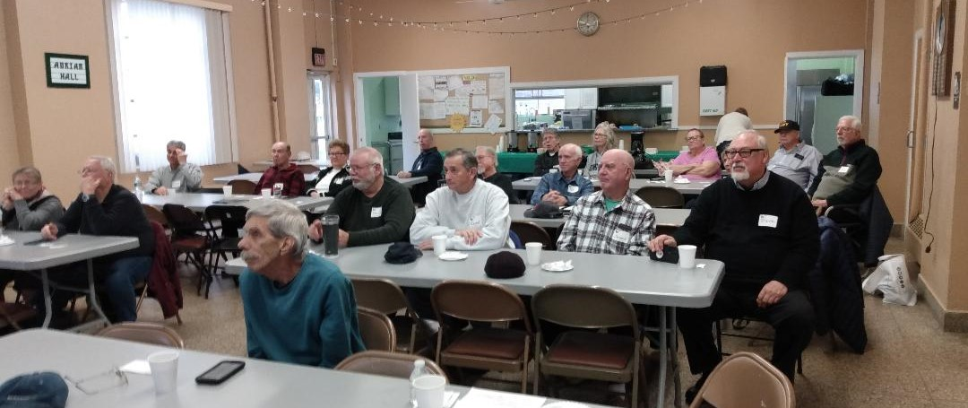OOur overarching theme was “…our backyard”
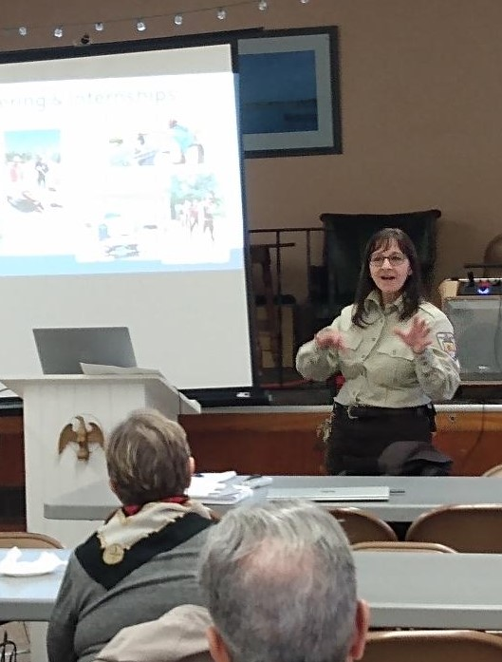
First up was Tracy Neal from Edwin B. Forsythe National Wildlife Refuge. Through her presentation on many of the different aspects and programs at the Refuge, members were heard saying … “Oh, I’ve been there” … “I’m going to go there” … and “I didn’t know that”. Literally in our back yard is that part of the saltmarsh restoration initiative of the mid Atlantic going on at Good Look Point. This involves spreading of compost and jute mats with planting of cord grass (Spartina) in the areas inland of Bayview Avenue. The intent is to reverse effects of sea level rise coupled with sinking of the marsh that has impacted surface nesting species. If you have seen/heard the airboat, that’s what’s going on.
For more information and opportunities to get involved at the refuge go to their website https://fws.gov>refuge>edwin-b-forsythe>visit-us
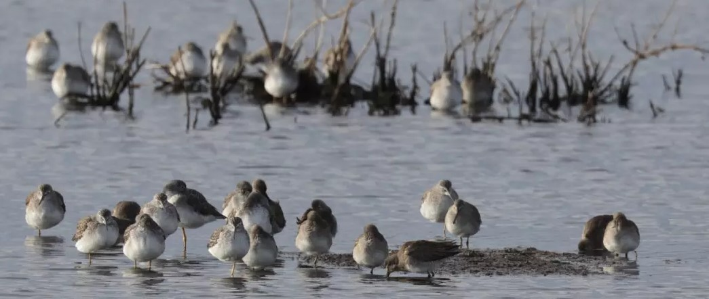

Lunch was provided by Richard’s Sub World, who, not coincidentally, is in our backyard. LOL Chips salads and cookies filled out the fare … as well as us!

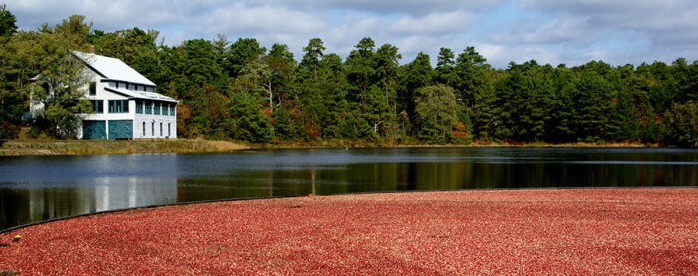
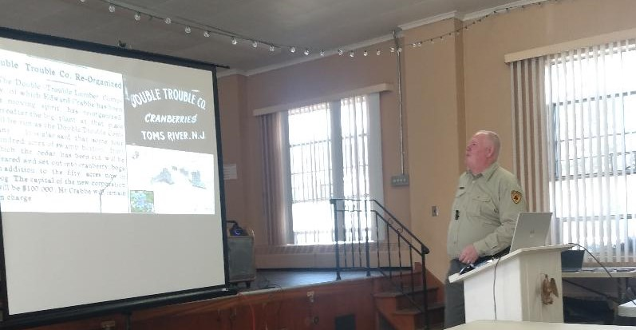
After lunch. Andrew Anderson, Historian, Double Trouble State Park shared with us how cedar lumbering and cranberry farming covered much of Ocean County. Our backyard, of course!
As economies changed cranberry bogs replaced the cedar forests. Of note, the Crabbe family’s predominance in both ”industries” and their presence/influence continues today. Log on to the park website for more on this significant part of Ocean County’s history. nj.gov/dep/parksandforests/parks/doubletroublestatepark.html

Third was Captain Mack Trotman and the 3 year restoration of the 1962 yacht Barnegat by DeRouville’s Boat Shop. The yacht is owned and managed by a consortium of 8 families of which the Crabbe family is a principle. The Crabbe family is active in much of sailing and boating on Barnegat Bay. No expense nor effort has been spared on this project as is evident in the product. DeRouville’s website chronicles many such restorations https://www.derouvillesboatshop.com
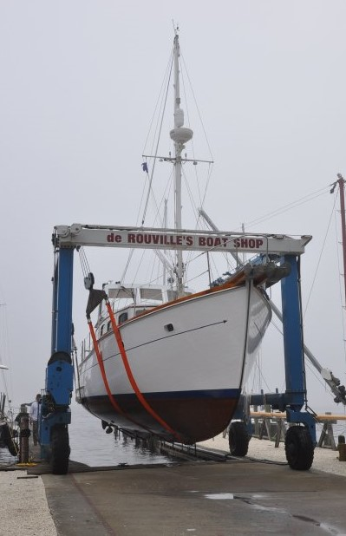
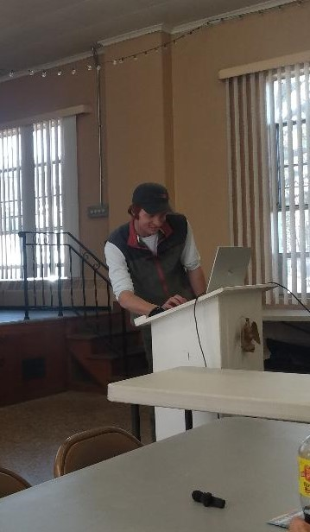
Mack Trotman is a truly remarkable young man. Age 23 … captain’s license since his teens and a student at Stevens Institute …. He led us on an adventure through the heart and soul of Barnegat over several years of (and ongoing) restoration. Mack is the master of the yacht and responsible for her wherever she goes. I don’t know how Jim Berrien does it but he continues to bring truly talented and informative presenters to us.

Maybe I’m stretching it to include a cruise to New Hampshire under the general theme of “our back yard” but Steve Stallsmith is one of our own and I feel sure to say that many of us live vicariously through his adventures with Dovekie. When most would head South in the Fall Steve set off North to Portsmouth. Why? As much his wanderlust, his son lives there. When you’re the guy who runs Tall Oaks racing in the Summer (from Dovekie) I guess that leaves the other three seasons for Cruising. A substantial part of Steve’s presentation had to do with preparation. Steve, the replete engineer (organized and methodical), gave me new ideas for my own cruising. Someone said to me once that with all that Pat and I do on the water that I should present (maybe I should present on what NOT to do since AGAIN I am the not-so-proud holder of the Pickled Sailor)…. No matter how much you are out there there’s always more to learn and Steve is a masterful teacher. I took away new (better) ways … such as how to inventory and organize stores and supplies
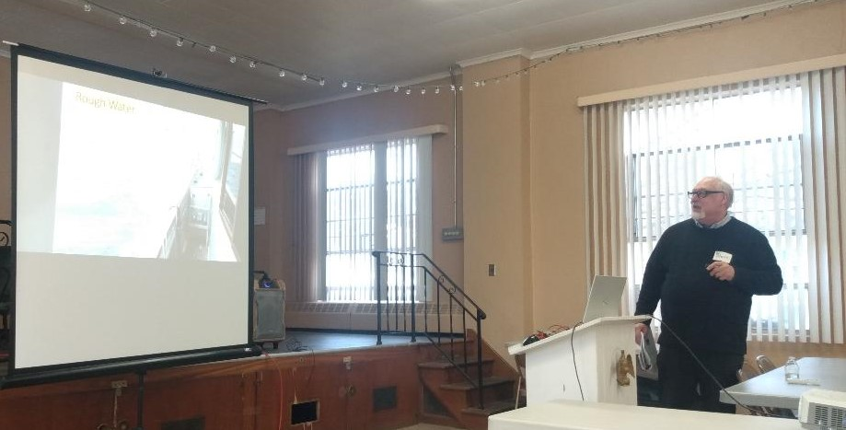
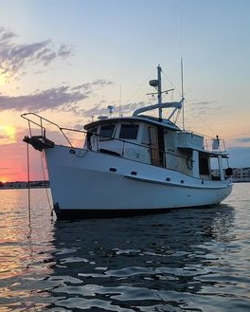

The state of the club is good. Not resting on our laurels with a successful 2024 seminar we are moving forward to club and individual events:
Sock Burning: Saturday, April 6, noon Silver Cloud Harbor Marina
Early Bird: Sunday, April 7, 3 – 5 pm Ocean gate Yacht Basin Grove
Flag Raising: Saturday, May 4, 10 am Ocean Gate Yacht Basin Grove
Memorial Weekend: Early reservations are strongly recommended! If you contact Farley or go through Dockwa be sure to mention that you are part of the CMYC/TOYC group. Hopefully they will gather us out on H dock as in the past. I will reach out to Austin (dockmaster) in the next couple of weeks to give him a heads up that we’re coming.
Vessel Safety Check: I have been in contact with the CG Auxiliary and Sarah at OGYB to organize a day when you can get your boat inspected. The inspections would be at OGYB. As plans develop I will keep you in the loop.
I hope all are well and, like me, looking forward to a banner year.
Regards,
Bill Templeton

